Abstract class and interface

public class InterfacevsAbstractDemo{
public static void main(String[] args) {
Dog dog = new Dog();
dog.eat();
dog.speak();
System.out.println("Dogs are "+dog.behaviour+"!");

Animal animal = new Dog();
animal.aBehaviour();
animal.speed();
}

}

abstract class Animal implements AnimalBehaviour{
String behaviour;

public Animal(){
this.behaviour ="Honest";
}

public abstract void speak();
public abstract void eat();
}

class Dog extends Animal {
Dog(){
super();
}

@Override
public void speak() {
System.out.println("Dog Barks");

}

@Override
public void eat() {
// TODO Auto-generated method stub
System.out.println("Dogs eat Bones");
}

@Override
public void aBehaviour() {
System.out.println("Dogs are adorable!");
}

@Override
public void speed() {
// TODO Auto-generated method stub
System.out.println("Dogs are fast enough!");

}
}

interface AnimalBehaviour{
public void aBehaviour();
public void speed();
}

/*
* one class extends abstract class or implements interface
* then it has to implements all of its methods.
*
* When abstract class implements interface it doesnt need to
* implement method of interface
*
* Abstract class can have constructors.
* When chlid class obj is instatiated constructors are called
*
* Abstract class can have a object with its child class object
* */

Sorting Alogorithhms

1. QuickSort
http://3.bp.blogspot.com/-2XKswkxXtE0/U8EkLJIt2BI/AAAAAAAABr0/0S34Aan5jMI/s1600/Quicksort-in-Java-example-fast.gif

2. MergeSort
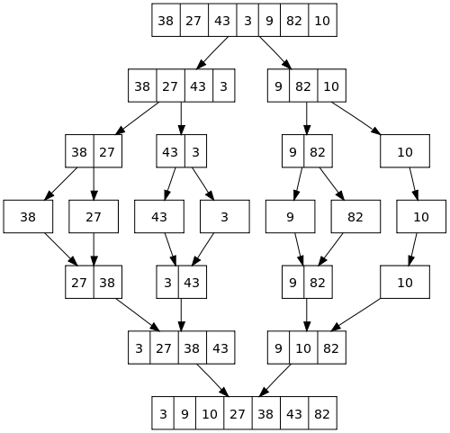

3. InsertionSort
i=0; j=1;
key = list[j];
compare and swap
4.BubbleSort
Compare each element till you get sorted list
i=0; j=1;
compare list[i] and list[j]
swap

5.Date

Add day in date:

<--- from java.util package --->
Date serviceDate = new DateTime(string).toDate;
Calendar calendar = Calendar.getInstance();
calendar.setTime(serviceDate);
//calendar.set(0, 0, 0, 11, 59, 59);
calendar.add(Calendar.DATE, 1);
calendar.add(Calendar.SECOND, -1);
serviceDate=calendar.getTime();

or
Date serviceDate = new DateTime(string).toDate;
long dateLong = serviceDate.getTime+(8*60*60+59*60+59)*1000;
Date newDate = Date(dateLong);

